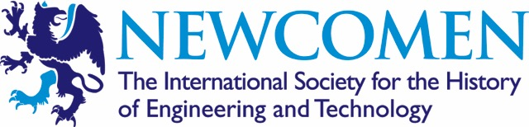

Newcomen Society, South Yorkshire, Meetings Programme 2017
___________________________________________________________________

Meetings Venue:-
Meetings are held at Kelham Island Museum, Alma Street, Sheffield S3 8RY, at 6.30 – 8.15pm unless otherwise indicated. Visitors are always very welcome and no charge is made for attending the lectures.
For directions to Kelham Island Museum please visit:- http://www.simt.co.uk/find-us
For further information please contact John Suter on:- meetings.syorks@newcomen.com
___________________________________________________________________

Monday 23rd January 2017, 6.30 pm

Deborah Jaffé: Frank Hornby and mechanical toys - Britain, Germany and the USA, 1880- 1950
___________________________________________________________________

Tuesday 21st February 2017, 5:30 pm Holiday Inn Royal Victoria, Sheffield Kenneth Barraclough Memorial Lecture

Professor Lord Mair CBE FREng FRS: The Brunels’ Thames Tunnel – a Great Legacy to Modern Tunnelling

This is a joint meeting with the Sheffield Metallurgical and Engineering Association and the South Yorkshire Industrial History Society. This talk is open to all and there is on site car parking providing you register your car at reception. The talk is followed by the SMEA Members’ Dinner. Contact Dr Ken Ridal (0114 230 5650 or kenridal@stonedelf.fsnet.co.uk).

___________________________________________________________________

Monday 13th March 2017, 6.30 pm

Professor David Perrett: Henry Ford's Holiday - Collecting British steam engines in 1928
___________________________________________________________________

Monday 24th April 2017, 6.30 pm

Professor Barry Chambers: Stealth - its history and technology
___________________________________________________________________

Thursday 11th to Saturday 13th May 2017

International Early Engines’ Conference, The Ironworks, Elsecar
___________________________________________________________________

